
Helen McGraw Branch
2180 E. Ridge Road
336-6060

The Friends of the Irondequoit Public Library Board would like to thank you for your generous support!
We are grateful for your contributions to help us fund the special Library programs that are not included in their budget.

The Friends is an all- volunteer organization.
which wholly supports and advocates for our Library as an essential asset in our community. The service the Library provides adds to the quality of life for every one in our town!

Your Memberships, generous donations and support of our fund-raisers help provide the variety of exciting Library programming for patrons of all ages, throughout the year.

Your support helps make these programs possible! If you are not already a member of The Friends, Please Join!

Friends of the
Irondequoit
Public Library

Late Fall, 2011

Great Library News! The Irondequoit Public Library & the Library Board of Trustees are delighted to report that, with your help, the 2012 Town Budget passed with the Library budget proposals intact. As a result, the Library Hours will be returning to pre- 2009 budget cut levels!
This is a first step in achieving the service the Library would like to be able to provide for their patrons!

Please Note that it will take some time to hire and train the new clerks who are needed to make these additional hours possible. The Library Staff greatly appreciates your continued patience while they work through this process. The Library will announce the date when the new hours will begin.

While the new hours will not be in effect for awhile, you can look forward to: Both

Pauline Evans Branch
45 Cooper Road
336-6062

branches being open Monday-Thursday from 10am-9pm. Evans will also be open again on Saturdays, from 10am-5pm, during the school
year. Fridays stay the same, with both Evans and McGraw open from 10am-6pm.

Please remember that these hours do not start until there is official word from the Library that they are in effect.

The Friends join the Library and the Library Board of Trustees in extending our profound thanks to all of you who took time to express your support to the
Supervisor and Town Board members over the last several months.



And, they listened! Please consider being in touch with them again (or, for the first time) to let the Supervisor and Town Board members know how much you appreciate their support of the Library!

The Friends want to thank everyone who stopped to see us at our table at the Irondequoit Farmer’s Market this season! To our many customers, the Town of Irondequoit and most especially the first-rate Market Manager, Donna Pecora, and her dynamic group of volunteers, all of your support was most appreciated!
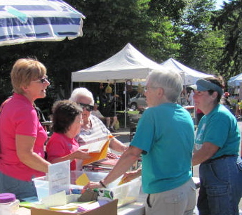
The Market offers a perfect opportunity for us to bring information about the great Library services to the public’s attention. Of course, that also includes programs that you help sponsor!

A Library connection bonus at the Market this year was Story Times by Miss Amy, Children’s
Librarian at Evans.
Miss Amy had such a good time that she will be coming back to the Farmers’ Market every week next summer!

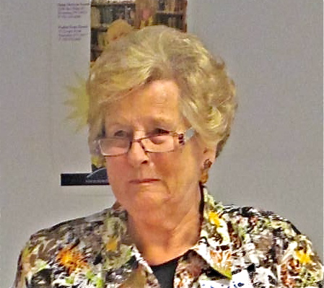
The Friends’ ongoing Library book sale at the Farmer’s Market was very well received! Your purchases of all those bargain books we had came to a total of $930, with the money equally divided between both our branches. You can find those same great deals year-round at the lobby book sales at both Library branches!

Flash! The Friends will be sponsoring a Library Book Sale Event on Saturday, February 11, 2012. The sale will be at the Evans Branch, lower level. Hours for the sale to be announced soon!

The Friends again had books for sale at the fall Community Garage Sale. Our thanks to all our terrific volunteers who helped us with the sale and a special thanks to Lee Steinfeldt for all her support on our behalf, the E.I. Alumni Assn and the Eastridge Robotics Team.

The Friends also had a table with Library information and books for sale at the delicious Rotary Pasta Dinner. Vendor tables were a new addition to the dinner this year and we welcomed this chance to be part of their event!

The Friends celebrated our many wonderful members at our Dessert Reception/ Annual Meeting in September. We were so happy that so many of you attended the event!

We were very privileged to have Pat Wayne, the
town historian, regale us with entertaining tales on the early histories of both the Library and The Friends!

We want to thank the young ladies of the Braham Crackers Book Club (Brenna, Robin, Abby, Heidi, Ally, Monica and Emel) for the very special book marks they hand made exclusively for the evening’s guests and for serving as the event’s junior ambassadors!

Everyone present at the reception had a great time! For those of you who were unable to attend, we missed you and hope you will join us in 2012!
Speaking of 2012, The Friends will celebrate our 40th Anniversary next year! We will be featuring that special milestone at all our events in 2012.

Save The Dates for two of our very exciting fundraising events that are already scheduled for 2012: The Friends are going to be Walking again! Join us Saturday, June 2, 2012 for our
Walk to Connect: The Irondequoit Library!


Get out your walking shoes for this second annual community favorite! Everyone had a fun time at our inaugural Walk, so be sure to include us in your plans for Saturday, June 2!

The Friends are happy to announce a new event on Saturday, April 14^{th,} 2011: A Historical Bus Tour showing off our town’s unique historical sites, with Pat Wayne as our first-rate tour guide! Look for more details to come about this first-time Friends fundraiser.

The Friends hope that you have been checking out the Library’s terrific new website: www.
irondequoitlibrary.org.
and while you are there, be sure to take a look at The Friends’ link to see our new blog!

And, while you are on Library website link to The Friends, look for the new, quick and easy way for you to donate to us by clicking on the Network for Good
button! Please note
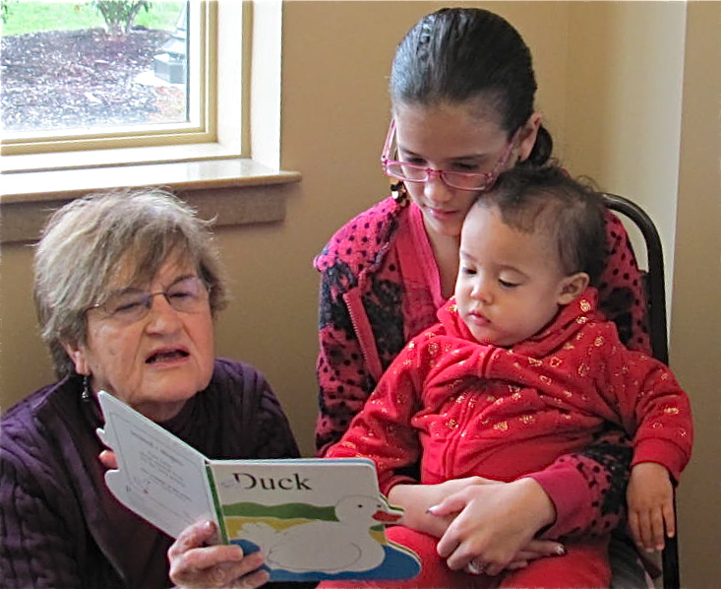
that there will be a 5% upfront service fee added to a contribution made on this site. The service fee goes to Network for Good (which is also a non-profit) for handling the transactions for us and means that The Friends receive the full amount of your donation.

Also coming soon: One of the perks to joining The Friends has been the eligibility to apply to become a member of the Irondequoit Federal Credit Union.

We are delighted to bring you news of a second Credit Union membership option for our members, as we are about to start the same arrangement with The Summit Federal Credit Union.

It is our pleasure to offer our Friends members the opportunity to apply for eligibility with either of these fine institutions.
As we have successfully done for so many years with the IFCU, we look forward to working with The Summit in this new and exciting partnership!

The Friends began our new collaboration with The Summit by being part of their Child Safety Awareness Day, earlier this fall. Along with the Irondequooit Police Department and the National Center for Missing and Exploited Children, we offered
Library information and
also read stories to the kids who had come to the event. It made this valuable service The Summit provided into a fun visit for everyone!

Library News With your help, 1000 cranes crafted by our own community will be winging their way to Japan as a symbol of our support following the devastation last March of their town during the earthquake & tsunami.
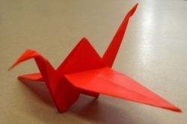
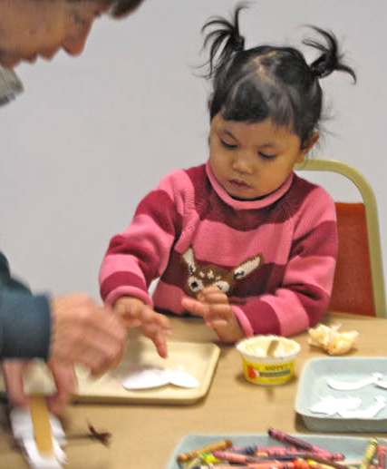
As part of the Library’s Summer Reading activities, the Library reached out to the community and you responded with your donations of beautiful paper cranes! McGraw branch has proudly displayed all your fine handiwork, adding each new crane to the display as the numbers quickly increased and the magic number of 1,000 was reached!

The cranes will be shipped to Shizugawa Junior High School in December. There is an additional hope that this gift to their students will spark an animated pen pal exchange!

“Books are a uniquely portable magic.” ~Stephen King

More Library News
There are still some very entertaining Library programs left for the fall season that your gifts to The Friends are helping to fund:

For adults, try Computer Basics at Evans on Monday, December 5, at 7pm. These classes are very popular Look for more to be coming up in the future!

Come for a festive Holiday Music Sing-A-Long for your whole family on Wednesday, December 7th, at 7pm.

On December 22, at 6:30p,, kids of all ages are invited to greet
an Amerks player and the Moose, at Evans!


And, don’t miss Winter Craft fun for kids, ages

5-12, on December 29th at McGraw.

Please take a look at the Library website or check with each branch for these program details and any registration information!

The new listings for the Winter programs will be out soon, so be sure to stop by either branch or look at them online at the Library’s website.

Consider Giving the Gift of a Book to the Library this Holiday Season. For a $25,00 donation you can Buy a Book for the Library in your name or to honor someone else on your gift list!!

For your generosity, a bookplate will be placed in the book, you can request a Holiday (or other suitable) themed certificate to announce your gift and you will receive a card good for (4) free holds, good (only) at the Irondequoit Public Library! More details are available at both branches.

Did you know that you can Talk to a Librarian online during Library hours! They can offer help with any of your Library oriented queries.
You can find the “Talk to a Librarian” button
about halfway down on the right side of the Library’s website home page and you can access it from other pages on the site, too.

The Library and the Library Board will be announcing an invitation for the community to come for a special visit and tour of each of the Library facilities. More information will be coming soon.

Special year-end thanks goes to the two men who take care of a full array of jobs, helping keep the Library branch buildings in functioning order. For their efforts year round, we salute Ron Drake and Frank Marra for their behind the scenes dedication to the Library, They are often asked to be creative wizards!! Our thanks for all your hard work!

Another year-end recognition goes to the landscape care that both the buildings receive:
At Evans, gardening volunteers offering their skill, time and energy are Sonya Christensen, and Jarmila Haseler. At McGraw, Gary Nenni of Sod Busters Landscape Service generously tends
the grounds and trees. Please accept the thanks of everyone who visits or works in the buildings for your handiwork!

The Friends’ 2010 edition of our Annual Report contained some errors and omissions, for which we are very sorry. We tried very hard to be accurate in our listings but extend our regrets to any members who were not included or whose listing was incorrect.

We wish to correct one glaring error we made: We were wrong in giving credit to Tomson-West for donating a matching fund amount to the very generous donation made to us by Deena and Gary Rocco. That was not true and no matching funds were ever sent. We offer Deena and Gary our sincere apologies for this undeserved listing.

If you would like to make a donation to the Irondequoit Food Cupboard during the Holiday season, or anytime during the year, the Evans branch of the Library is a drop-off donation site for the Cupboard!

Of course, only non-perishable items are accepted at the Library.

The location to drop off items at Evans is near the front windows, on the floor. Please ask a Library staff person if you need help in finding the correct location. The Cupboard has great need and all your donations will be most gratefully
received!

Visit the Cupboard’s website for more information: www.
irondequoitcommunitycupboard.org.

Library Hours:
Pauline Evans
M & Th. 10am-9pm
T & W 10am-5pm
Fri. 10am-6pm
Sat./Sun Closed
Helen McGraw
M & Th. 10am-5pm
T & W 10am-9pm
Fri. 10am-6pm
Sat. 10am-5pm
Sat. Summer Closed
Sun. Closed
Library Closings:
December 23rd, 24th, 26th and 31st, January 2nd and 16th
*HappyHolidays!*

